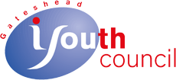

Annual Review 1st April 2019 to 31st March 2020

Whilst the reporting period was mostly before ‘lockdown’ we have written it during lockdown so it is in a different format as we aren’t having our usual AGM.
2019 was a bit of a struggle, we had very little by way of funds but managed to do a lot, with not much, as you will see. We found it almost impossible to find enough time to dedicate to large funding bids without sacrificing the face to face work with the young people. We did however recruit board members who are going to work on this and hope to see a significant increase in funding and capacity over the coming year.
So, what did we actually do? Well, still quite a bit.
Sue Adams, Chairperson, GYC

April saw our current Vice Chair of Gateshead Youth Council Board of Trustees, Lucy Adams, be announced as a recipient if the Diana Award for her Humanitarian work. We are so very proud!
We spent more time again with Mortals Fools this time watching the finished show at Caedmon Hall. Their performance of I-Weigh was inspiring. We also visited the Live Theatre watching a performance of Drip. Drip was a show written and performed by one young man. It was hilarious, and thought provoking, a tale of getting sucked into something to support your best mate, in this case, a guy who can’t swim committing to a synchronised swimming display. We like to support local venues, in line with our ‘local pound’ commitment. This was also an important part of the young peoples’ Arts Awards.

In May our fantastic Pakora Party hosted a drop in café for National Vegetarian Week. It was extremely popular and Gladstone terrace could have been filled many times over.
GYC also hosted a brilliant session with Dawn and Sara from the Rape Crisis Tyneside and Northumberland. They came to talk about sexual assault/harassment, sexism and which people are more likely to be victims of sexual assault. Shocking but needs to be made aware of!
Involve North East and The Mental Health Trailblazer delivered a very interesting and topical workshop this month too. Hopefully this will help young people tackle mental health and help people understand.

Balance Northeast came in June to discuss the dangers and misrepresentation of alcohol. That prompted a very animated discussion! It’s a topic our young people feel very strongly about – being manipulated by marketing.

July involved Valerie, Sue and Lucy having a brief trip to London (they really suffer for GYC!). Following Lucy being announced as a recipient, there was a very posh event at the House of Lords where Lucy received her award. Who knew there was Pimms on tap in the House of Lords?
July also sees the memorial week for the Srebrenica genocide. To mark this, Gateshead Council lit up the Millennium Bridge green in an act of remembrance.
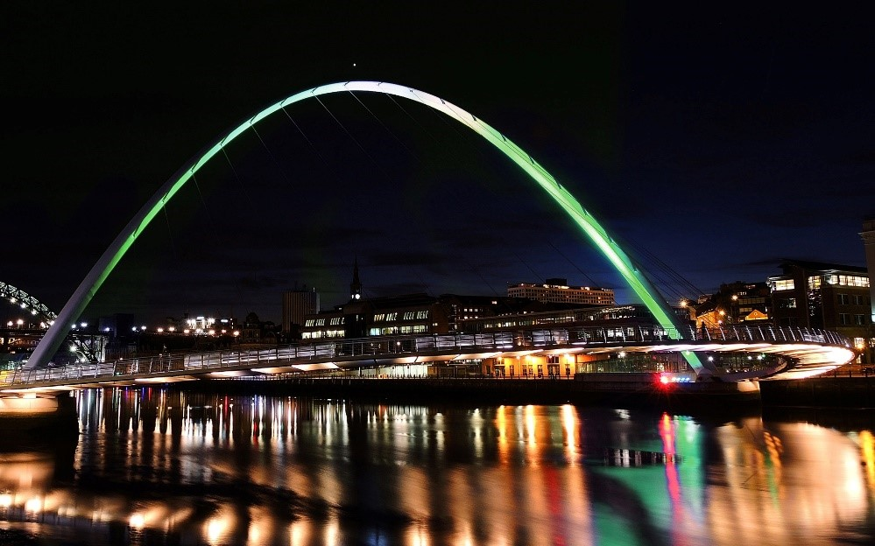

GYC invited Stephanie Hancock and Sarah Kilpatrick from the National Education Union in to talk about SATs and how they affect children's mental health, and how they impact their futures. High stakes testing is a very emotive issue and so, so important from a mental health point of view. We discovered that SATs aren’t used by many Secondary Schools to stream year 7 students, and they are only used to ranks Primary Schools. Also, interestingly, you don’t have to sit them.

August saw a new project for GYC – Project Tom. GYC had taken over the Red Box Project previously and, when Red Box achieved their aim of getting free sanitary products in schools, they closed their project. We felt it so important that no one has to struggle for the lack of sanitary products, so our young people created Project ToM (Time of the Month). The aim of Project ToM is to make free products available in community venues and schools, for young people, and older women. This project is the brainchild of Freya and Sophie who have worked hard to get funding and make care packages for many, many young women.
We had our summer residential at Gibside #PutYourPositivePantsOn. So much work was done there and we have to thank Greggs for making it happen. Money is always tight and this took the strain off. We’re very grateful. We also had a visit from Sarah Kilpatrick following up on our work earlier in the year on High Stakes testing. Hector the puppy was a great addition too!!
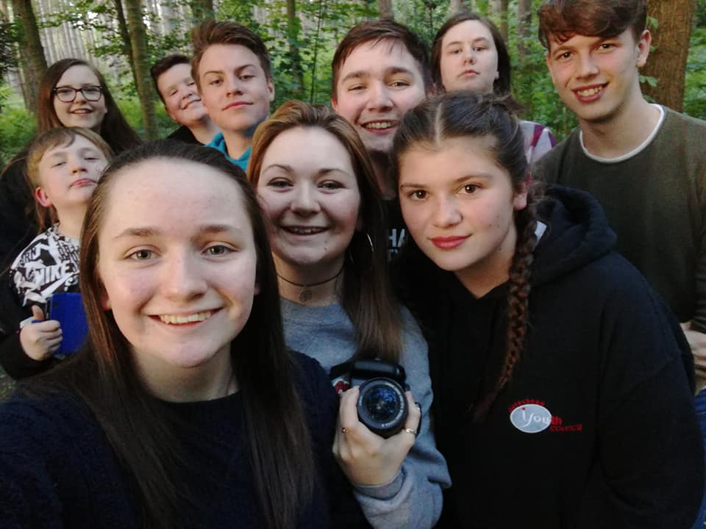

In September Ben Dickenson held a fantastic workshop – all about City of Dreams plans for the future with our young people at the heart of it. Makes us very proud to live in the North East.
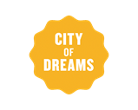

We also said a fond farewell to some longstanding members of GYC. They didn’t get too far though – some have now become Board Members!

October is often a quiet month – work continued on our project and art Projects. We have very dedicated young people.
We have such amazing Board members - Mahnoor had a fabulous time at the North East Charity Awards having been nominated for an award for her amazing and inspiring work. Valerie took one for the team and went along with her!

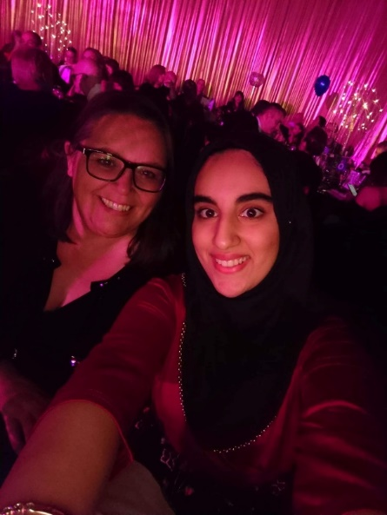

November is always a very important month – not only do we meet the new Gateshead Youth Assembly members but our young people take part in the Civic Remembrance Day event. Freya and Sophie represented the young people of Gateshead at the Remembrance Service at the Cenotaph. They recited ‘In Flanders Fields’ and laid wreaths on behalf of Gateshead Youth Council and Gateshead Youth Assembly.
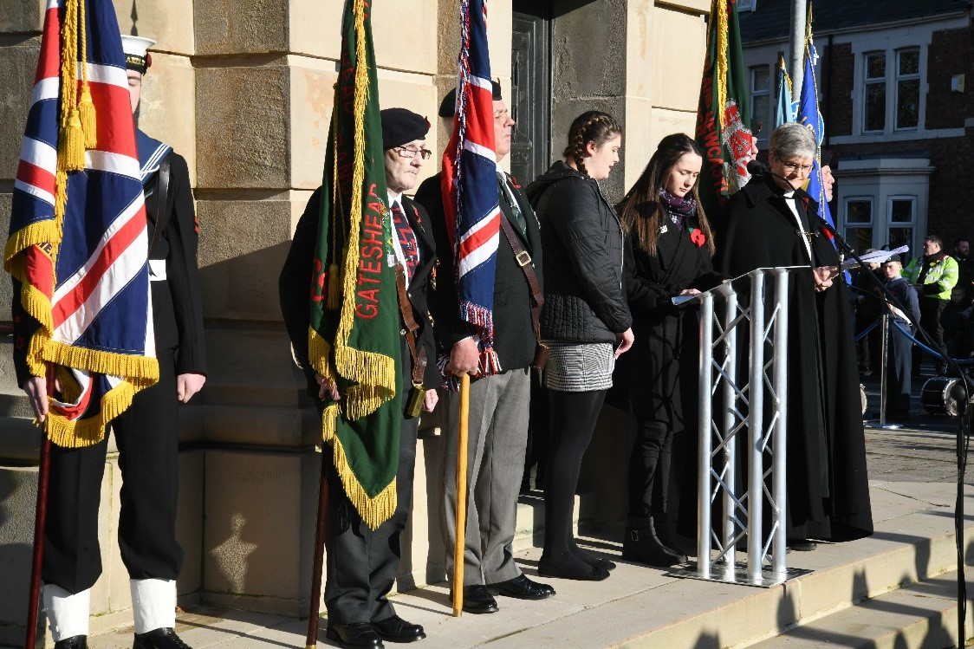

December saw GYC young people attend a City of Dreams Champions Board meeting where plans were made for the future of City of Dreams and events for 2020 planned. We also had our annual Christmas party, which is a casual and low key as you like but sees young people have some much needed social time, as well as collecting goodies to donate to Asylum seeking Children and Young People.

January 2020 started well, and busy, but toward the end we were starting to realise the this Coronovirus thing was going to have an impact on our work. We spoke to our Young People and made plans to move online using Zoom if we had to close the doors.

In February we started to move our IMPACT course online, and while it’s not perfect, it’s better than nothing.

Like everyone else March saw massive changes, we had to close the doors to our young people, which is something we hate and never imagined we would do. But, Zoom, Teams and Facebook Messenger came into their own. We have logged as many hours online as we did in real life, it’s OK, technology is great, but we still hanker for face to face sessions!

Thanks as ever to our amazing Young People, and their parents and carers, to Gateshead Council, Northumbria Police, QE Gateshead, The Key, The High Sheriff, Greggs, City of Dreams, Balance, NEU, Gibside Estate, United Way, Tyne and Wear Community Foundation, the Vegetarian Society and Valerie and Anthony Ender for their birthday donations!
